**INSTITUTE OF ENGINEERING**

ADVANCED COLLEGE OF ENGINEERING AND MANAGEMENT

KALANKI, KATHMANDU

(AFFILIATED TO TRIBHUVAN UNIVERSITY)



**LAB REPORT**

**SUBJECT: SIMULATION & MODELING**

**LAB NO: 01**

**SUBMITTED BY:** **SUBMITTED TO:**

NAME: DIPESH DHUNGANA DEPARTMENT OF COMPUTER

ROLL NO: ACE077BCT035 AND ELECTRONICS

DATE: December 27, 2024

**TITLE**: SIMULATION OF CHEMICAL REACTION

**OBJECTIVE**:

* TO PLOT THE CONCENTRATION GRAPH OF REACTANTS AND PRODUCT WITH TIME

UNDER A CONTROLLED ENVIRONMENT

* TO UNDERSTAND THE APPLICATION OF SIMULATION AND MODELING

**THEORY**:

Modeling is like creating a simplified representation of a real-world system or process. It's like building a miniature model of a car to understand how it works without having to build the actual car. Simulation is like running experiments on that model to see how it behaves under different conditions. It's like testing the miniature car in a wind tunnel to see how it performs at high speeds.

For example, Imagine wanting to understand how traffic flows on a busy road. Instead of building an actual road and watching cars drive on it, we can create a simple computer model of the road. This model includes things like the road's length, the number of lanes, and where traffic lights are. Then, we can use this model to pretend cars are driving on the road and see how they move and interact with each other. This helps us figure out where traffic might get stuck, how long it takes to drive on the road, and what we can do to improve traffic flow without actually changing the real road.

The following are some common applications of simulation and modelling:

* **Engineering & Manufacturing**: From designing aircraft to optimizing factory layouts, simulations help engineers predict product performance, identify potential failures, and streamline production processes, leading to cost-effectiveness and improved quality.
* **Healthcare & Medicine**: Simulations empower medical professionals with realistic training scenarios, allowing them to hone their skills in a safe and controlled environment. Drug development is accelerated through simulations that predict drug interactions and efficacy, while disease modeling aids in understanding disease spread and developing effective control strategies.
* **Business & Economics**: In the business world, simulations are invaluable for forecasting market trends, optimizing supply chains, and managing financial risks. By creating virtual representations of business scenarios, companies can test different strategies, identify potential pitfalls, and make informed decisions that maximize profits and minimize losses.
* **Environmental Sciences**: Understanding and mitigating environmental challenges rely heavily on simulation and modeling. Climate models help predict the impacts of global warming, while ecosystem simulations aid in conservation efforts. By simulating natural disasters, we can better prepare for and respond to their devastating effects.
* **Transportation & Urban Planning**: From optimizing traffic flow to designing efficient public transportation networks, simulations play a crucial role in creating sustainable and efficient urban environments. By simulating various scenarios, city planners can identify bottlenecks, improve infrastructure, and enhance the overall quality of life for residents.
* **Defense & Military**: In the defense sector, simulations provide a safe and cost-effective way to train soldiers, test military equipment, and evaluate strategic plans. By simulating combat scenarios, military personnel can develop critical decision-making skills and improve their operational effectiveness.
* **Education & Training**: Simulations transform learning experiences by creating immersive and interactive environments. From virtual laboratories to flight simulators, students can engage with complex concepts in a hands-on manner, enhancing their understanding and developing practical skills.

**Continuous System**

Continuous system can be defined asa system where change occurs smoothly over time without abrupt jumps or discrete steps. Imagine a flowing river. The water level changes smoothly over time, not in sudden jumps. This is a classic example of a continuous system. These systems are often described using differential equations, which show how the rate of change of something depends on its current state. The following are the types of differential equations:

* **Ordinary Differential Equation**: It is the equation which consists of a single independent variable along with the higher order derivative of the dependent form.

𝑀 𝑥’’ + 𝐷 𝑥’ + 𝐾 𝑥 = 𝐾 𝐹(𝑡)

Here x is the dependent variable, t is the independent variable whereas F(t) is the function of independent variable, M, D, and K are constants.

* **Partial Differential Equation**: The differential equation is said to be partial if more than one independent variable occurs in a differential equation.

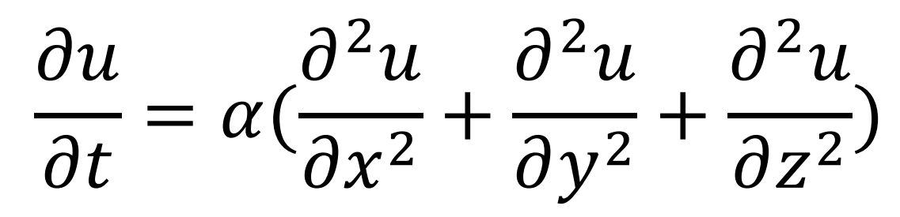

Here u is the dependent variable with x, y, and z as the independent variables.

**Chemical Reaction**

Chemical reactions are fundamental processes that involve the transformation of one or more substances (reactants) into different substances (products) through the rearrangement of atoms. During a chemical reaction, the bonds between atoms in the reactants are broken, and new bonds are formed to create the products. This rearrangement often involves the release or absorption of energy, which can manifest as heat, light, or other forms of energy. Chemical reactions are ubiquitous in nature and essential for life itself. They underpin various phenomena, from the combustion of fuels to the digestion of food and the photosynthesis in plants. Understanding the principles of chemical reactions is crucial in fields like chemistry, biology, and materials science, enabling advancements in areas such as drug development, energy production, and environmental remediation.

The concentration of reactant and product change smoothly over time and also the reaction occurs in controlled environment. An example of chemical reaction is below:

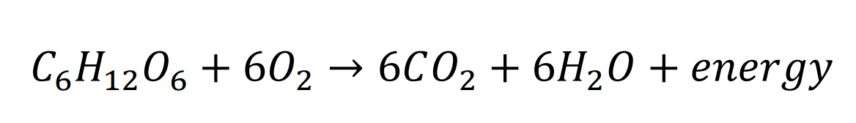

Above is the chemical reaction that happens when glucose is reacted with oxygen which gives carbon dioxide and water with the release of energy. It is conducted by plants at night when the sunlight is absent.

**SOURCE CODE**

import numpy as np

import matplotlib.pyplot as plt

# Parameters

k1 = 0.03

k2 = 0.01

dt = 0.1

steps = 30

# Initial concentrations

c1 = [50.0] # Reactant A

c2 = [25.0] # Reactant B

c3 = [0.0] # Product C

# Open a file to write the results

with open("output.txt", "w") as file:

# Write initial concentrations

file.write(f"{c1[0]} {c2[0]} {c3[0]}\n")

# Time-stepping loop for concentration updates

for i in range(steps):

# Calculate next concentrations based on the given equations

c1_next = c1[i] + (k2 * c3[i] - k1 * c1[i] * c2[i]) * dt

c2_next = c2[i] + (k2 * c3[i] - k1 * c1[i] * c2[i]) * dt

c3_next = c3[i] + (2 * k1 * c1[i] * c2[i] - 2 * k2 * c3[i]) * dt

# Append the new concentrations to the lists

c1.append(c1_next)

c2.append(c2_next)

c3.append(c3_next)

# Write concentrations to the file

file.write(f"{c1_next} {c2_next} {c3_next}\n")

# Time points for plotting

time_points = np.arange(0, (steps + 1) * dt, dt)

# Plotting the results

plt.figure(figsize=(10, 6))

plt.plot(time_points, c1, label='Concentration of c1', color='blue')

plt.plot(time_points, c2, label='Concentration of c2', color='green')

plt.plot(time_points, c3, label='Concentration of c3', color='red')

plt.xlabel('Time (s)')

plt.ylabel('Concentration')

plt.title('Concentration vs Time')

plt.legend()

plt.grid(True)

plt.show()

**OUTPUT**

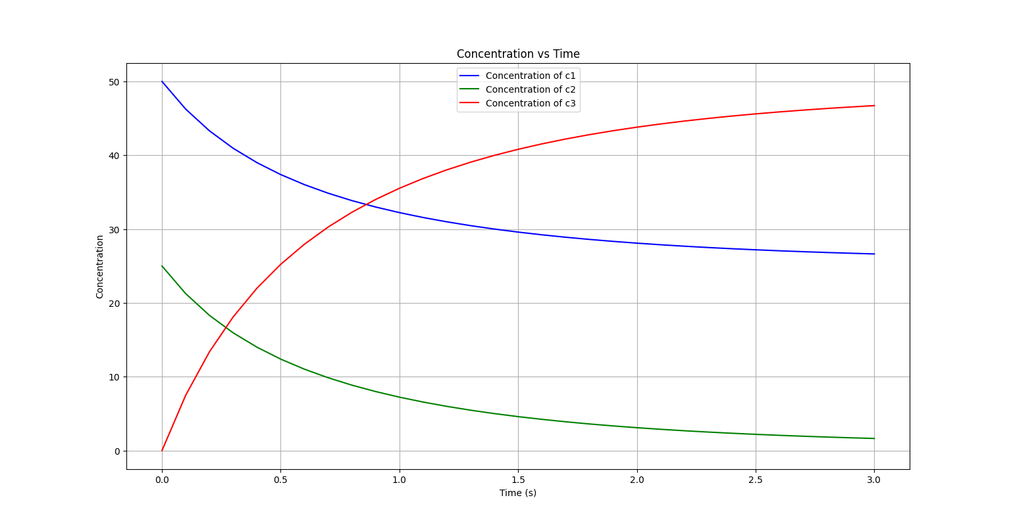

***(****GRAPH OF REACTANTS AND PRODUCT WITH TIME)*

**DISCUSSION AND CONCLUSION**:

In this lab, we simulated a chemical reaction using Python. We observed that reactant concentrations decreased while the product concentration increased over time, demonstrating typical reaction behavior. The simulation results showed a non-linear relationship between concentration and time, as expected in chemical reactions.

We considered two reactants c1 and c2 to form a product c3. The initial concentration of the reactants c1 and c2 is assumed to be 50 mol and 25 mol respectively while the concentration of c3 is 0. The change in concentrations of the three compounds are governed by the following set of equations:  
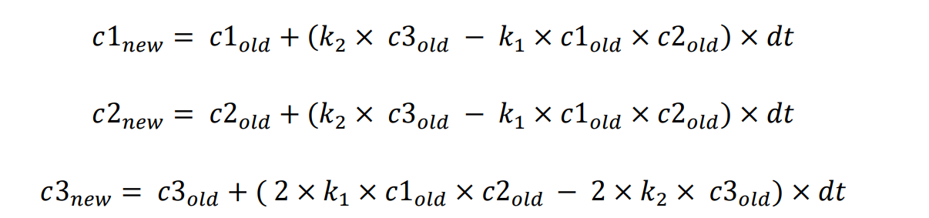

The reaction is carried out till number of steps is completed and the parameters are initialized as follows: k1 = 0.03, k2 = 0.01, dt = 0.1, steps = 30

we used python libraries numpy and matplotlib for simulation to observe the overall conditions of a chemical reaction by plotting the graph of the reactants and products with respect to time governed by the equations which determined the concentration of the particular compound in the next instance. From the graph we can say that the concentration has a non-linear relationship with time and concentration of reactants are decreasing while the concentration of product is increasing. Thus, with the help of simulation we can model various real-life scenarios in a safe and controlled way as we need which helps in gaining valuable knowledge without the expense of valuable resources.